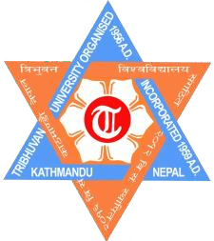

Tribhuvan University

**Institute of Science and Technology (IoST)**

**Patan Multiple Campus**

A lab report on: ……………

Lab report no: …………….

Submitted by

Name: Roll No.: Section:

Submitted to

Department of CSIT

Date:

**To familiarize with computer systems hardware**

**Hardware:**

All the electronic devices that we can touch & feel are called hardware. Hardware is a tangible component such as a motherboard, hard disk, RAM, ROM, CPU & printer, etc.

**Different hardware components:**

**Motherboard:**

The motherboard is a computer's central communications

backbone connectivity point, connecting all components and external peripherals. The motherboard supplies power to the processor, RAM, hard disk, and other hardware components. It houses every wire and connector you can see inside the case. It also houses the famous RAM (Random Access Memory), also known as primary memory. The motherboard also houses other important components such as a graphics card, LAN 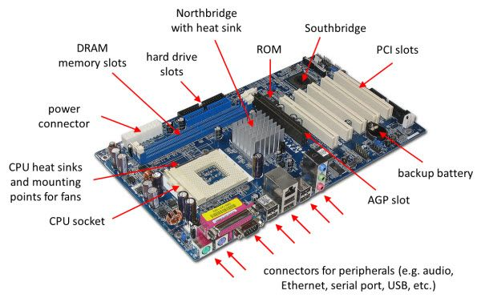card, etc.

**Memory**:

Memory is a device that can store information. A memory unit is the amount of data that the memory can hold. Besides, we measure this storage capacity in terms of bytes. Moreover, there are different units of memory as per the requirement.

**Primary Memory**:

This is the internal memory that stores the data and instructions of the CPU. It is volatile (data is lost when the power is disconnected).

The primary memory has two types:

**1.RAM:**

RAM (random access memory) is a computer's short-term memory, where the data that the processor is currently using is stored. Your computer can access RAM much faster than data on a hard disk, SSD, or other long-term storage device, which is why RAM capacity is critical for system performance.

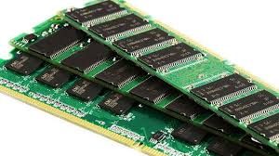.

**2.ROM:**

Read-only memory (ROM) is a type of non-volatile memory that stores data that can't be changed or modified after the device is manufactured. ROM contains the programming that allows a computer to start up or regenerate each time it is turned on.

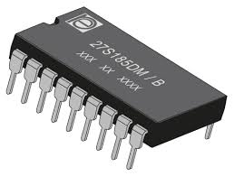

**Hard disk:**

A computer hard disk drive (HDD) is a non-volatile data storage device. Non-volatile refers to storage devices that maintain stored data when turned off. **hard disk**, [a magnetic](https://www.britannica.com/science/magnetism) storage medium for a [computer](https://www.britannica.com/technology/computer). Hard disks are flat circular plates made of [aluminum](https://www.britannica.com/science/aluminum) or [glass](https://www.britannica.com/technology/glass) and coated with a magnetic material. Hard disks for [personal computers](https://www.britannica.com/technology/personal-computer) can store terabytes (trillions of bytes) of information

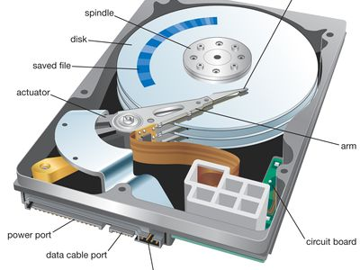

**CMOS battery:**

A CMOS (Complementary Metal-Oxide-Semiconductor) battery is a small, coin-shaped battery found on a computer’s [motherboard](https://www.hp.com/us-en/shop/tech-takes/what-does-a-motherboard-do). It provides power to the CMOS chip, which stores important system information such as the date, time, and hardware settings in the CMOS memory.

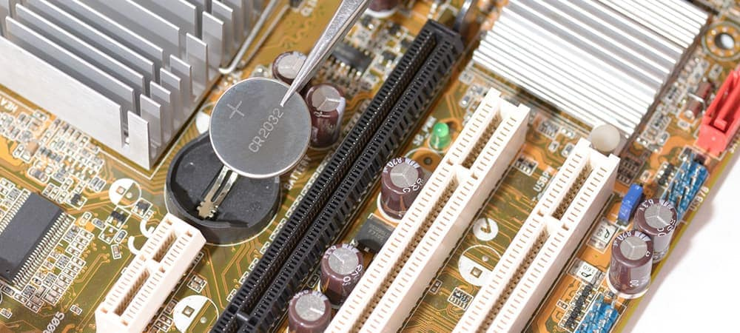

**Power supply unit:**

A computer's power supply unit (PSU) is a hardware device that converts alternating current (AC) from an electrical outlet into direct current (DC) for the computer's components to use. The PSU is usually located at the top or bottom of the computer case, and the power cord plugs into it.It is normally located in the upper corner of the enclosure and is equipped with a small fan to prevent overheating.

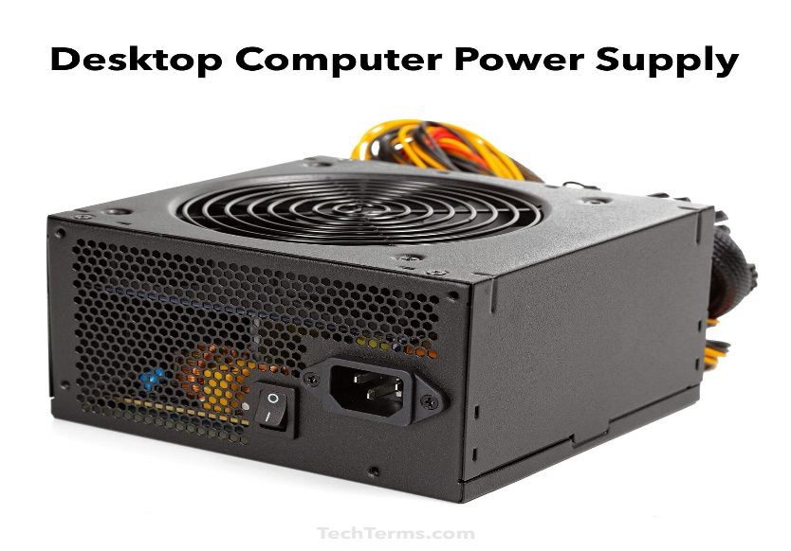

**Processor (CPU):**

The Central Processing Unit (CPU) is the primary component of a computer that acts as its “control center.” The CPU also referred to as the “central” or “main” processor, is a complex set of electronic circuitries that runs the machine's operating system and apps. It provides the instructions and processing power the computer needs to do its work. The more powerful and updated your processor, the faster your computer can complete its tasks.

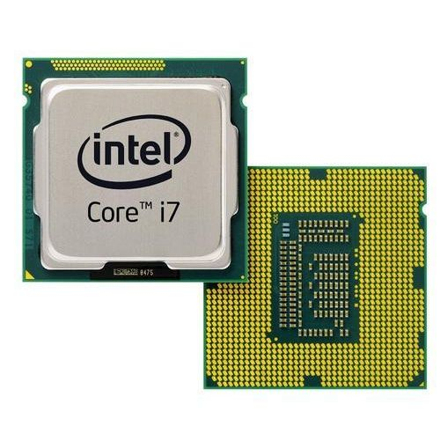

**Conclusion:**

In this practical, we explored and analyzed the fundamentals of computer systems hardware to understand their role and functionality in digital systems. By examining the components, operations, and interactions within hardware. This practical serves as a foundational step in developing expertise in computer systems, preparing us for more complex studies in digital technology and system architecture.